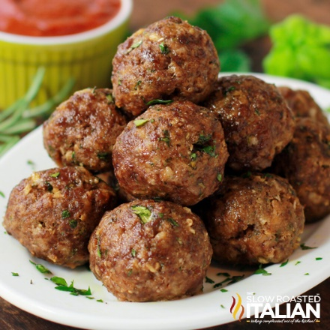
Italian Herb Baked Meatballs
Prep time 30 min Cook time 20 min
7 Servings
Ingredients
1 lb lean ground beef
½ cup Italian breadcrumbs
¼ cup fresh grated parmesan cheese
2 garlic cloves, minced
½ small yellow onion finely chopped
2 tbsp marinara
1 tbsp fresh rosemary, chopped
1 tbsp fresh parsley, chopped
1 tbsp fresh basil, chopped
½ tsp kosher salt
¼ tsp fresh cracked black pepper
1 large egg, lightly beaten
Directions
- Preheat oven to 375 degrees. Spray a baking dish with cooking spray.
- In a large bowl, beat egg and combine all dry ingredients and mix well.
- Add to ground beef. Do not over mix or the meatballs will be tough.
- Using a 2 tablespoon scoop, portion out meat and place onto a plate. After all meatballs have been scooped, roll into balls and place into the baking dish.
- Bake for 15 to 16 minutes convection oven (20 to 22 minutes oven), until the meatballs are browned and cooked through.
- Remove and transfer to sauce or serve immediately.

